Advanced Games Programming
Tutorial 04 - Constant Buffers

Introduction

Vertices are not the only information that you can pass to your shaders. You can also send them variables to use, as you would with a normal C/C++ program. The mechanism that DirectX11 uses to pass additional data as variables to shaders is called a constant buffer. A constant buffer allows you to pass data that can be shared amongst all the vertices being processed by shaders. For instance let's say you wanted to vary the red component of all vertices of a model by a single fraction. You could do it by adjusting and uploading all of the vertices (you may have done it this very way if you did the additional exercises in Tutorial 03), but this quickly becomes very slow and inefficient as models get larger. A much better way of doing this would be to use a single value that is uploaded, and you can do this using constant buffers.

Creating and Using a Constant Buffer

The adjustment of vertices red values by a fraction will serve as a simple example. In order to use constant buffers it's best to start off with looking at how a constant buffer might be declared at the beginning of the shader.hlsl file:

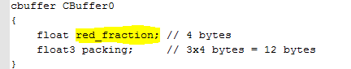

This cbuffer is very much like a struct in C/C++, and it is used in a very similar way to compartmentalise variables that are linked together, in this case various shader variables. Additionally the cbuffer is closely linked to a struct in your C/C++ code that is used to upload the data, more on this later. This particular constant buffer is called CBuffer0, but this name is not relevant at the moment, what is more relevant is how its element red_fraction is used in the following vertex shader:

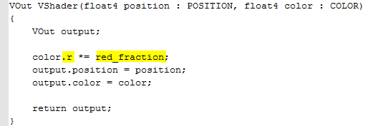

Notice the difference accessing the element between this and a struct, the red_fraction element is accessed directly in a shader, whereas a struct in C/C++ would use the form CBuffer0.red_fraction. CBuffer0 also has a 3 element float called packing, the reason for this unused element will become apparent later.

The first vertex shader you used in the last tutorial simply copied the position and colour data from the input vertices to the vertex shader output structure. This time, however, there is something else happening to the vertex data before it gets output. In this case the idea is to multiply the red component by a fractional value provided using the constant buffer, and the way to do this is use the dot operator to access the red component individually. This works in a similar way to C/C++ structure access, the color element has been defined as a float4 in the shader, and this means it has four floating point elements that can be accessed with r, g, b and a (these are used in colour contexts, float4 can be accessed using x, y, z and w as well if you are dealing with positional data). So in order to modify just the red portion of the colour, color.r can be used, obviously you can use the other elements if you wish. Where the shader element access differs from C/C++ is that you can specify multiple elements to be updated with the same value, e.g. color.rg, color.rgb or, color.rb etc.

As mentioned previously, in order to upload data to the constant buffer you need a struct to match the cbuffer declaration in the shader, so here is one that could be declared as a global in main.cpp:

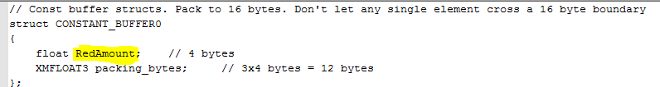

You will probably immediately notice that none of the names match those in the cbuffer. In fact, the only thing that has to match is the ordering and the size of the variables. There are various issues when using a large number of elements in a single constant buffer to do with packing and 16 byte boundaries, but these will be discussed later.

Now that you have a struct that describes your constant buffer layout you will need to create the constant buffer itself. First off you would need a global constant buffer pointer:

Then in InitialiseGraphics() you would create the constant buffer as you did the vertex buffer:

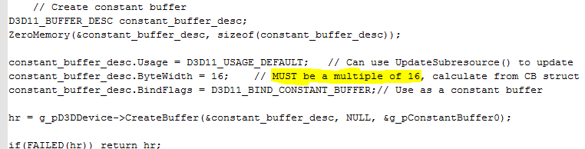

There are some differences. For instance Usage is defined as D3D11_USAGE_DEFAULT, and there is no setting of CPU write access in CPUAccessFlags. This is because you can use a function called UpdateSubresource() to update the constant buffer, which will be explained shortly. Probably the area most likely to cause difficulty is the ByteWidth attribute. This needs to be a multiple of 16 as constant buffers are uploaded in 16 byte chunks, so unless you have taken care to pack your constant buffer struct to a 16 byte multiple then using sizeof() won't be good enough. As it happens CONSTANT_BUFFER0 declared above has used packing to ensure it is 16 bytes long, but it is always worth manually double checking.

Another even harder to spot problem occurs if any single element of the constant buffer struct overlaps a 16 byte boundary. For instance:

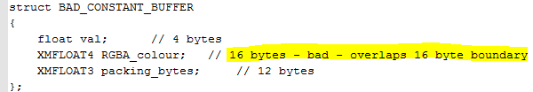

Though this seems correctly packed to 32 bytes there is a hidden problem. If any single element, in this case the 16 byte RGBA_colour, overlaps a 16 byte boundary then the shader compiler moves it up to be aligned to the 16 byte boundary. If this happens then your system and video memory versions will not match when you update, with unpredictable results.

00 |  | 04 |  | 08 |  | 12 |  | 16 |  | 20 |  | 24 |  | 28 |  | 32 |  | 36 |  | 40 |  | 44 |  | 48
System memory

val |  | RGBA_colour |  |  |  |  |  |  |  | packing_bytes
│ Video memory
└──────moved──────>
val |  | UNUSED |  |  |  |  |  | RGBA_colour |  |  |  |  |  |  |  | packing_bytes

To update the constant buffer you need to create a buffer structure, fill in the values, then update the structure in video memory by calling UpdateSubresource().

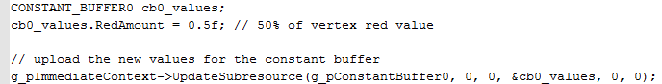

The parameters that are 0 are not relevant to constant buffers, and the other 2 are pretty obvious. If you were updating the buffer every frame then a good place for the update might be in the RenderFrame() function, before the triangle is drawn.

After updating the constant buffer you should set the constant buffer to be active using:

The first 2 parameters represent which constant buffer slot to start at, and how many buffers to set. In this case there is only 1 buffer, and it's set at slot 0.

Finally you must clean up on exit by calling:

Make sure this is called before the device and immediate context are released.

Exercise 01 - Using constant buffers
- Create a new project based on your Tutorial 03 - Exercise 01 project (or one of the extra/advanced exercises), renaming it in the correct way.
- Comment out any code that updates vertices.
- Implement the above C++ and shader code to enable and use constant buffers.
- Make sure all of the vertices you've defined have at least some red component.
- Run the code a few times altering the variable RedAmount, say from 0.0 to 5.0, to see if it correctly changes how much red is output. Alternatively, add code that varies the value continuously, or via keyboard/mouse.
Key codes can be found here: https://docs.microsoft.com/en-us/windows/desktop/inputdev/virtual-key-codes

Exercise 02 - Using a constant buffer variable to scale vertices
- Create a new project based on your Tutorial 04 - Exercise 01 project, renaming it in the correct way.
- Add another float variable called scale to the cbuffer and the constant buffer struct. Make sure you correctly adjust the packing for both.
- Add C++ code to update scale at the same time as RedAmount. Add code that varies the value continuously, or via keyboard/mouse through a range of values you choose.
- Add code to your shader that modifies the x coordinate of the output position by the value of scale. What happens? Is it what you expected?
- Add more code that also modifies the y coordinate by the inverse of scale, that is (1.0 - scale)
- Comment out the previous 2 lines that update x and y, and try :
What happens now? Does it do what you expect? Research and try to explain what the shader is doing, and why.
Note: You may want to change the position vertices to a smaller value like 0.2f to better see what is going on

